Add a Link in Blackboard to SmartEvals

DMACC collects course evaluations through an online system called SmartEvals. Near the end of the term, both you and your students receive emails that indicate when the evaluation period begins and ends for each course as well as reminders. These emails also contain links to each course’s evaluation.

Now you can link to the evaluations directly from your Blackboard course, making access easier for you and your students! Follow the instructions below to set up your SmartEvals link.

Note: SmartEvals links are tied to users’ login, so users can only view their own evaluations.

- Log into Blackboard and click on the class in which you want to add the SmartEvals link.
- From the Course Content area, click into the folder where you want to add the SmartEvals link (based on its evaluation period).
- From the top navigation bar, click the Build Content drop-down menu and click on SmartEvals Course Content.

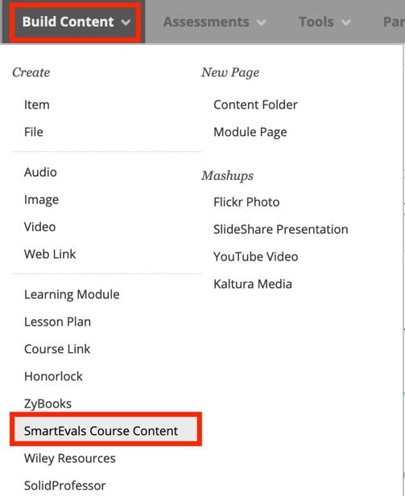

- On the next screen, add your title and a description.
  - Sample: “Please click on the link above to complete the brief﻿ course survey. All responses are anonymous. Your feedback is important to me and will be used to improve the course. Thank you﻿﻿﻿﻿﻿﻿﻿!”
- Choose your settings and click Submit. ﻿﻿﻿﻿﻿﻿﻿﻿﻿﻿﻿﻿﻿﻿﻿﻿﻿﻿﻿﻿﻿﻿﻿﻿﻿
- You can now move the link up or down within the folder for proper sequencing.

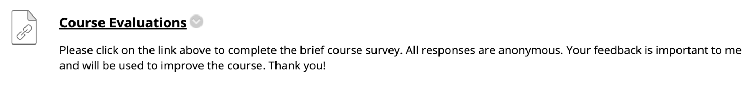

- That’s it! Your SmartEvals course link has been created.

